http://www.dotnettricks.com/learn/oops/object-oriented-programming-concepts:
Object-Oriented Programming Concepts (www.dotnettricks.com)
Author : Shailendra Chauhan
Posted On : 15 Feb 2011
Updated On : 10 Jul 2012

Object-Oriented Programming Concepts
OOP is a design philosophy. It stands for Object Oriented Programming. Object-Oriented Programming (OOP) uses a different set of programming languages than old procedural programming languages (C, Pascal, etc.). Everything in OOP is grouped as self-sustainable "objects". Hence, you gain re-usability by means of four main object-oriented programming concepts. Below are object oriented programming concepts:
- Object
Object is representative of the class and is responsible for memory allocation of its data members and member functions. An object is a real world entity having attributes (data type) and behaviors (functions).
An object can be considered a "thing" that can perform a set of related activities. The set of activities that the object performs defines the object behavior. For example, the hand can grip something or a Student (object) can give the name or address
- Class
Class is a data structure that contains data members (constants files, events), member function methods, properties, constructor, destructor, indexers and nested type. Basically
  - It is a user defined data type.
  - It is a reference type.
  - Infact class is a tag or template for object.
- Encapsulation
Encapsulation is a mechanism of binding the data member & member function into a single unit known as class. Encapsulation provides a way for abstraction. In OOP the encapsulation is mainly achieved by creating classes, the classes expose public methods and properties. The class is kind of a container or capsule or a cell, which encapsulate the set of methods, attribute and properties to provide its indented functionalities to other classes.
- Data abstraction
Data abstraction is a mechanism to provide the essential features without describing the background details. Means provide the functions to access the hidden (private) data.
The importance of abstraction is derived from its ability to hide irrelevant details and from the use of names to reference objects. Abstraction is essential in the construction of programs. It places the emphasis on what an object is or does rather than how it is represented or how it works. Thus, it is the primary means of managing complexity in large programs.
- Data Hiding
Data hiding is a mechanism to hide the internal structure of an object from rest of the program. In a class private members are hidden from the rest of the program, hence it supports data hiding. Data hiding is also a way to implement data abstraction.
- Polymorphism
Polymorphism means one thing in many forms. Basically polymorphism is capability of one object to behave in multiple ways. Example: A man role changes at home, college, and outside the home. There are following types of polymorphism:
  - Static polymorphism (compile time): It is achieved using function overloading and operator overloading.
  - Dynamic polymorphism (runtime time): It is achieved using function overriding means using virtual function.

Difference between function and method
In programming langauages we have two concepts functions and methods. functions are defined in structural language and methods are defined in object oriented langauge. The difference between both is given below :

Functions
- Functions have independent existence means they can be defined outside of the class. Ex:- main() function in C, C++ Language
- Functions are defined in structured languages like Pascal,C and object based language like javaScript
- Functions are called independently.
- Functions are self describing unit of code.

- //function main in C
- void main()
- {
- int a,b,c;
- a=5;
- b=6;
- c=a+b;
- printf("Sum is : %d",c);
- }

Methods
- Methods do not have independent existence they are always defined with in class. Ex:- main() method in C# Language that is defined with in a class
- Methods are defined in object oriented languages like C#, Java
- Methods are called using instance or object.
- Methods are used to manipuate instance variable of a class.
- //method sum in C#
- class demo
- {
- int a,b,c;
- public void sum()
- {
- a=5;
- b=6;
- c=a+b;
- Console.WriteLine("Sum is : {0}",c);
- }
- }

Understanding Association, Aggregation, Composition and Dependency relationship
A relationship defines the connection between objects. This explains how objects are connected to each other’s and how they will behave.

Association
It represents a relationship between two or more objects where all objects have their own lifecycle and there is no owner. The name of an association specifies the nature of relationship between objects. This is represented by a solid line.
Let’s take an example of relationship between Teacher and Student. Multiple students can associate with a single teacher and a single student can associate with multiple teachers. But there is no ownership between the objects and both have their own lifecycle. Both can be created and deleted independently.


Aggregation
It is a specialized form of Association where all object have their own lifecycle but there is ownership. This represents “whole-part or a-part-of” relationship. This is represented by a hollow diamond followed by a line.
Let’s take an example of relationship between Department and Teacher. A Teacher may belongs to multiple departments. Hence Teacher is a part of multiple departments. But if we delete a Department, Teacher Object will not destroy.
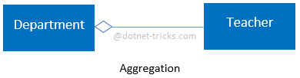

Composition
It is a specialized form of Aggregation. It is a strong type of Aggregation. In this relationship child objects does not have their lifecycle without Parent object. If a parent object is deleted, all its child objects will also be deleted. This represents “death” relationship. This is represented by a solid diamond followed by a line.
Let’s take an example of relationship between House and rooms. House can contain multiple rooms there is no independent life of room and any room cannot belongs to two different house if we delete the house room will automatically delete.
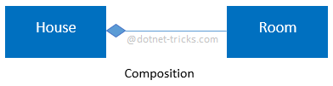
Let’s take another example of relationship between Questions and options. Single questions can have multiple options and option cannot belong to multiple questions. If we delete questions options will be automatically deleted.

Dependency
It represents a relationship between two or more objects where an object is dependent on another object(s) for its specification or implementation. This is represented by a dashed arrow.
Let’s take an example of relationship between client and service. A client is dependent on the service for implementing its functionalities.
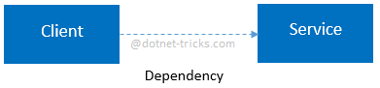
Let’s take another example of relationship between a client and a supplier. A client is dependent on the supplier for supplying products. If the supplier will not supply the products, client cannot use those products.

Understanding Inheritance and Different Types of Inheritance
Inheritance is a mechanism of acquiring the features and behaviors of a class by another class. The class whose members are inherited is called the base class, and the class that inherits those members is called the derived class. Inheritance implements the IS-A relationship.
For example, mammal IS-A animal, dog IS-A mammal; Hence dog IS-A animal as well.

Advantages
- Reduce code redundancy.
- Provides code reusability.
- Reduces source code size and improves code readability.
- Code is easy to manage and divided into parent and child classes.
- Supports code extensibility by overriding the base class functionality within child classes.

Disadvantages
- In Inheritance base class and child classes are tightly coupled. Hence If you change the code of parent class, it will get affects to the all the child classes.
- In class hierarchy many data members remain unused and the memory allocated to them is not utilized. Hence affect performance of your program if you have not implemented inheritance correctly.

Different Types of Inheritance
OOPs supports the six types of inheritance as given below-
- Single inheritance
In this inheritance, a derived class is created from a single base class.
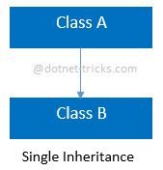
  - //Base Class
  - class A
  - {
  - public void fooA()
  - {
  - //TO DO:
  - }
  - }

  - //Derived Class
  - class B : A
  - {
  - public void fooB()
  - {
  - //TO DO:
  - }
  - }
- Multi-level inheritance
In this inheritance, a derived class is created from another derived class.
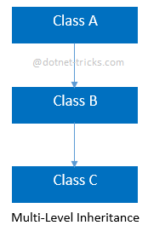
  - //Base Class
  - class A
  - {
  - public void fooA()
  - {
  - //TO DO:
  - }
  - }

  - //Derived Class
  - class B : A
  - {
  - public void fooB()
  - {
  - //TO DO:
  - }
  - }

  - //Derived Class
  - class C : B
  - {
  - public void fooC()
  - {
  - //TO DO:
  - }
  - }
- Multiple inheritance
In this inheritance, a derived class is created from more than one base class. This inheritance is not supported by .NET Languages like C#, F# etc.
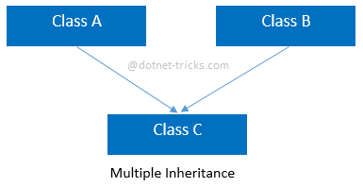
  - //Base Class
  - class A
  - {
  - public void fooA()
  - {
  - //TO DO:
  - }
  - }

  - //Base Class
  - class B
  - {
  - public void fooB()
  - {
  - //TO DO:
  - }
  - }

  - //Derived Class
  - class C : A, B
  - {
  - public void fooC()
  - {
  - //TO DO:
  - }
  - }
- Multipath inheritance
In this inheritance, a derived class is created from another derived classes and the same base class of another derived classes. This inheritance is not supported by .NET Languages like C#, F# etc.
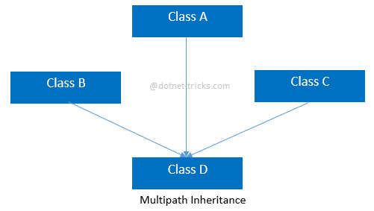
  - //Base Class
  - class A
  - {
  - public void fooA()
  - {
  - //TO DO:
  - }
  - }

  - //Derived Class
  - class B : A
  - {
  - public void fooB()
  - {
  - //TO DO:
  - }
  - }

  - //Derived Class
  - class C : A
  - {
  - public void fooC()
  - {
  - //TO DO:
  - }
  - }

  - //Derived Class
  - class D : B, A, C
  - {
  - public void fooD()
  - {
  - //TO DO:
  - }
  - }
- Hierarchical inheritance
In this inheritance, more than one derived classes are created from a single base.
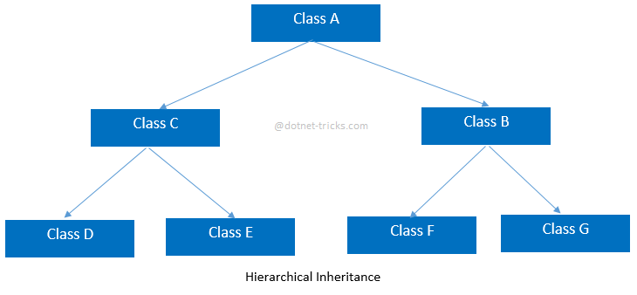
  - //Base Class
  - class A
  - {
  - public void fooA()

  - {
  - //TO DO:
  - }
  - }

  - //Derived Class
  - class B : A
  - {
  - public void fooB()
  - {
  - //TO DO:
  - }
  - }

  - //Derived Class
  - class C : A
  - {
  - public void fooC()
  - {
  - //TO DO:
  - }
  - }

  - //Derived Class
  - class D : C
  - {
  - public void fooD()
  - {
  - //TO DO:
  - }
  - }

  - //Derived Class
  - class E : C
  - {
  - public void fooE()
  - {
  - //TO DO:
  - }
  - }

  - //Derived Class
  - class F : B
  - {
  - public void fooF()
  - {
  - //TO DO:
  - }
  - }

  - //Derived Class
  - class G :B
  - {
  - public void fooG()
  - {
  - //TO DO:
  - }
  - }
- Hybrid inheritance
This is combination of more than one inheritance. Hence, it may be a combination of Multilevel and Multiple inheritance or Hierarchical and Multilevel inheritance or Hierarchical and Multipath inheritance or Hierarchical, Multilevel and Multiple inheritance.
Since .NET Languages like C#, F# etc. does not support multiple and multipath inheritance. Hence hybrid inheritance with a combination of multiple or multipath inheritance is not supported by .NET Languages.
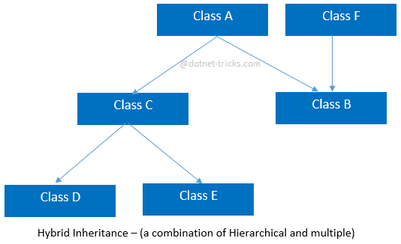
  - //Base Class
  - class A
  - {
  - public void fooA()
  - {
  - //TO DO:
  - }
  - }

  - //Base Class
  - class F
  - {
  - public void fooF()
  - {
  - //TO DO:
  - }
  - }

  - //Derived Class
  - class B : A, F
  - {
  - public void fooB()
  - {
  - //TO DO:
  - }
  - }

  - //Derived Class
  - class C : A
  - {
  - public void fooC()
  - {
  - //TO DO:
  - }
  - }

  - //Derived Class
  - class D : C
  - {
  - public void fooD()
  - {
  - //TO DO:
  - }
  - }

  - //Derived Class
  - class E : C
  - {
  - public void fooE()
  - {
  - //TO DO:
  - }
  - }

Difference Between Generalization and Specialization
The process of extracting common characteristics from two or more classes and combining them into a generalized superclass, is called Generalization. The common characteristics can be attributes or methods. Generalization is represented by a triangle followed by a line.

Specialization is the reverse process of Generalization means creating new sub classes from an existing class.
Let’s take an example of Bank Account; A Bank Account is of two types – Current Account and Saving Account. Current Account and Saving Account inherits the common/ generalized properties like Account Number, Account Balance etc. from a Bank Account and also have their own specialized properties like interest rate etc.
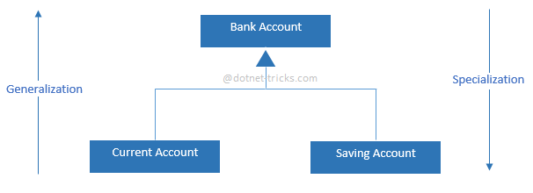

CRUD Operations using jQuery dialog, Entity Framework and ASP.NET MVC
This article will demonstrate, how to create an Asp.Net MVC application with CRUD (Create, Read, Update, Delete) Operations using jQuery and Entity Framework code first. suppose you have following data model and DataContext classes in EF.
- public class User
- {
- public int UserID { get; set; }
- [Required(ErrorMessage = "Please Enter Your Name")]
- public string Name { get; set; }
- [Required(ErrorMessage = "Please Enter Your Address")]
- public string Address { get; set; }
- [Required(ErrorMessage = "Please Enter Your Contact No")]
- public string ContactNo { get; set; }
- }

- public class DataContext : DbContext
- {
- public DataContext()
- : base("DefaultConnection")
- {

- }

- public DbSet<User> Users { get; set; }
- }
Now migrate your data model class into SQL Server database by using EF code first database migration. For more help refer this link Understanding Entity Framework Code First Migrations

Create Operation
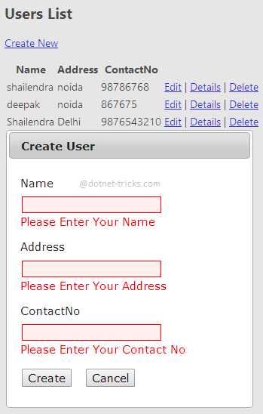
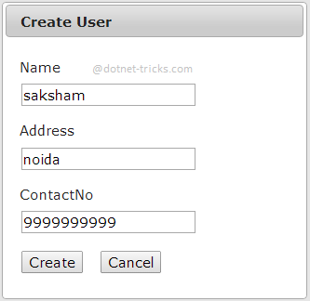
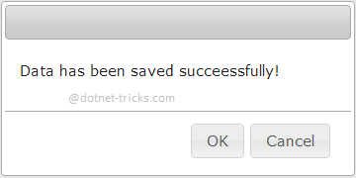

Read Operation
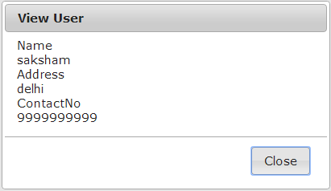

Update Operation
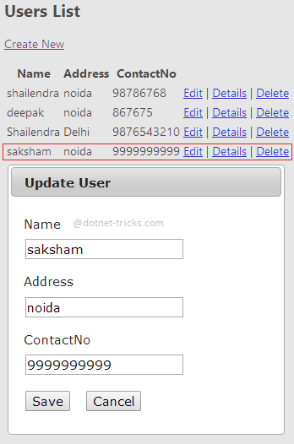
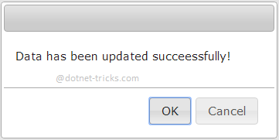

Delete Operation
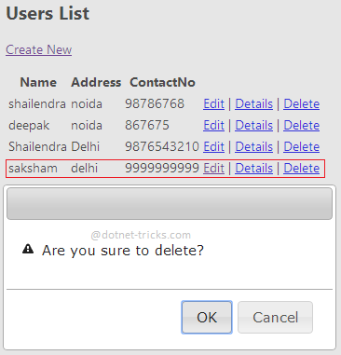
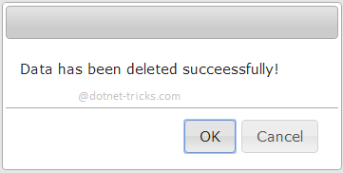

Making jQuery dialogs for CRUD Operations
- @model IEnumerable<jQuery_CRUD.DAL.User>
- @{
- ViewBag.Title = "Index";
- }
- <script src="~/Scripts/jquery-1.8.2.min.js"></script>
- <script src="~/Scripts/jquery-ui-1.8.24.min.js"></script>
- <link href="~/Content/themes/base/jquery-ui.css" rel="stylesheet" />
- <script>
- $(document).ready(function () {
- var url = "";
- $("#dialog-alert").dialog({
- autoOpen: false,
- resizable: false,
- height: 170,
- width: 350,
- show: { effect: 'drop', direction: "up" },
- modal: true,
- draggable: true,
- open: function (event, ui) {
- $(".ui-dialog-titlebar-close").hide();
- },
- buttons: {
- "OK": function () {
- $(this).dialog("close");

- },
- "Cancel": function () {
- $(this).dialog("close");
- }
- }
- });

- if ('@TempData["msg"]' != "") {
- $("#dialog-alert").dialog('open');
- }

- $("#dialog-edit").dialog({
- title: 'Create User',
- autoOpen: false,
- resizable: false,
- width: 400,
- show: { effect: 'drop', direction: "up" },
- modal: true,
- draggable: true,
- open: function (event, ui) {
- $(".ui-dialog-titlebar-close").hide();
- $(this).load(url);
- }
- });

- $("#dialog-confirm").dialog({
- autoOpen: false,
- resizable: false,
- height: 170,
- width: 350,
- show: { effect: 'drop', direction: "up" },
- modal: true,
- draggable: true,
- open: function (event, ui) {
- $(".ui-dialog-titlebar-close").hide();

- },
- buttons: {
- "OK": function () {
- $(this).dialog("close");
- window.location.href = url;
- },
- "Cancel": function () {
- $(this).dialog("close");
- }
- }
- });

- $("#dialog-detail").dialog({
- title: 'View User',
- autoOpen: false,
- resizable: false,
- width: 400,
- show: { effect: 'drop', direction: "up" },
- modal: true,
- draggable: true,
- open: function (event, ui) {
- $(".ui-dialog-titlebar-close").hide();
- $(this).load(url);
- },
- buttons: {
- "Close": function () {
- $(this).dialog("close");
- }
- }
- });

- $("#lnkCreate").live("click", function (e) {
- //e.preventDefault(); //use this or return false
- url = $(this).attr('href');
- $("#dialog-edit").dialog('open');

- return false;
- });

- $(".lnkEdit").live("click", function (e) {
- // e.preventDefault(); use this or return false
- url = $(this).attr('href');
- $(".ui-dialog-title").html("Update User");
- $("#dialog-edit").dialog('open');

- return false;
- });

- $(".lnkDelete").live("click", function (e) {
- // e.preventDefault(); use this or return false
- url = $(this).attr('href');
- $("#dialog-confirm").dialog('open');

- return false;
- });

- $(".lnkDetail").live("click", function (e) {
- // e.preventDefault(); use this or return false
- url = $(this).attr('href');
- $("#dialog-detail").dialog('open');

- return false;
- });

- $("#btncancel").live("click", function (e) {
- $("#dialog-edit").dialog("close");
- return false;
- });
- });
- </script>
- <div id="dialog-alert" style="display: none">
- <p>
- @TempData["msg"]!
- </p>
- </div>

- <div id="dialog-confirm" style="display: none">
- <p>
- <span class="ui-icon ui-icon-alert" style="float: left; margin: 0 7px 20px 0;"></span>
- Are you sure to delete?
- </p>
- </div>

- <div id="dialog-edit" style="display: none">
- </div>
- <div id="dialog-detail" style="display: none">
- </div>

- <h2>Users List</h2>

- <p>
- @Html.ActionLink("Create New", "Create", null, new { id = "lnkCreate" })
- </p>
- <table>
- <tr>
- <th>
- @Html.DisplayNameFor(model => model.Name)
- </th>
- <th>
- @Html.DisplayNameFor(model => model.Address)
- </th>
- <th>
- @Html.DisplayNameFor(model => model.ContactNo)
- </th>
- <th></th>
- </tr>

- @foreach (var item in Model)
- {
- <tr>
- <td>
- @Html.DisplayFor(modelItem => item.Name)
- </td>
- <td>
- @Html.DisplayFor(modelItem => item.Address)
- </td>
- <td>
- @Html.DisplayFor(modelItem => item.ContactNo)
- </td>
- <td>
- @Html.ActionLink("Edit", "Edit", new { id = item.UserID }, new { @class = "lnkEdit" }) |
- @Html.ActionLink("Details", "Details", new { id = item.UserID }, new { @class = "lnkDetail" }) |
- @Html.ActionLink("Delete", "Delete", new { id = item.UserID }, new { @class = "lnkDelete" })
- </td>
- </tr>
- }

- </table>

Controller for handling CRUD Operations
- public class UserController : Controller
- {
- private DataContext db = new DataContext();

- // GET: /User/
- public ActionResult Index()
- {
- return View(db.Users.ToList());
- }

- // GET: /User/Details/5
- public ActionResult Details(int id = 0)
- {
- User user = db.Users.Find(id);
- if (user == null)
- {
- return HttpNotFound();
- }
- return View(user);
- }

- // GET: /User/Create
- public ActionResult Create()
- {
- return PartialView();
- }

- // POST: /User/Create
- [HttpPost]
- [ValidateAntiForgeryToken]
- public ActionResult Create(User user, string Command)
- {
- if (ModelState.IsValid)
- {
- db.Users.Add(user);
- db.SaveChanges();
- TempData["Msg"] = "Data has been saved succeessfully";
- return RedirectToAction("Index");
- }

- return View(user);
- }

- // GET: /User/Edit/5
- public ActionResult Edit(int id = 0)
- {
- User user = db.Users.Find(id);
- if (user == null)
- {
- return HttpNotFound();
- }
- return View(user);
- }

- // POST: /User/Edit/5
- [HttpPost]
- [ValidateAntiForgeryToken]
- public ActionResult Edit(User user)
- {
- if (ModelState.IsValid)
- {
- db.Entry(user).State = EntityState.Modified;
- db.SaveChanges();
- TempData["Msg"] = "Data has been updated succeessfully";
- return RedirectToAction("Index");
- }
- return View(user);
- }

- // GET: /User/Delete/5
- public ActionResult Delete(int id)
- {
- User user = db.Users.Find(id);
- db.Users.Remove(user);
- db.SaveChanges();
- TempData["Msg"] = "Data has been deleted succeessfully";
- return RedirectToAction("Index");
- }

- protected override void Dispose(bool disposing)
- {
- db.Dispose();
- base.Dispose(disposing);
- }
- }

Server Side Model Validation in MVC Razor
Server side validations are required for ensuring that the received data is correct and valid. If the received data is valid then we do the further processing with the data. Server side validations are very important before playing with sensitive information of a user.
Server-side validation must be done whether we validate the received data on the client side. User could disable script in his browser or do something else to bypass client-side validation. In this case server-side validation must required to protect our data from dirty input.

Server-side model validation technique
In MVC Razor, we can validate a model server side by below two ways:
- Explicit Model Validation
- Model Validation with Data Annotations

Explicit Model Validation
Suppose, you want to validate the registration process of a user for which the Registration model and view are defined as below:

RegistrationModel.cs
- public class RegistrationModel
- {
- public string UserName { get; set; }
- public string Password { get; set; }
- public string ConfirmPassword { get; set; }
- public Country Country { get; set; }
- public City City { get; set; }
- public string Address { get; set; }
- public string MobileNo { get; set; }
- public bool TermsAccepted { get; set; }
- }

- public class Country
- {
- public int? ID { get; set; }
- public string Name { get; set; }
- }

- public class City
- {
- public int? ID { get; set; }
- public string Name { get; set; }
- public int? Country { get; set; }
- }

ExplicitServer.cshtml
- @model Mvc4_Client_ServerSideValidation.Models.RegistrationModel
- @{
- ViewBag.Title = "Explicit Server Side Validation";
- }
- <script src="../../Scripts/jquery-1.7.1.min.js" type="text/javascript"></script>
- <script type="text/jscript">
- $(function () {
- $('#Country_ID').change(function () {
- var id = $("#Country_ID :selected").val();
- if (id != "") {
- $.ajax({
- type: "GET",
- contentType: "application/json; charset=utf-8",
- url: '@Url.Action("CityList", "Home")',
- data: { "mCountry": id },
- dataType: "json",
- success: function (data) {
- var items = "";
- $.each(data, function (i, city) {
- items += "<option value='" + city.Value + "'>" + city.Text + "</option>";
- });
- $('#City_ID').html(items);
- },
- error: function (result) {
- alert('Service call failed: ' + result.status + ' Type :' + result.statusText);
- }
- });
- }
- else
- {
- var items = '<option value="">Select</option>';
- $('#City_ID').html(items);
- } });
- });
- </script>
- <h2>Explicit Server Side Validation</h2> @using (Html.BeginForm())
- {
- <fieldset>
- <ol>
- <li>
- @Html.LabelFor(m => m.UserName)
- @Html.TextBoxFor(m => m.UserName, new { maxlength = 50 })
- @Html.ValidationMessageFor(m => m.UserName)
- </li>
- <li>
- @Html.LabelFor(m => m.Password)
- @Html.PasswordFor(m => m.Password, new { maxlength = 50, value = ViewBag.Selpwd })
- @Html.ValidationMessageFor(m => m.Password)
- </li>
- <li>
- @Html.LabelFor(m => m.ConfirmPassword)
- @Html.PasswordFor(m => m.ConfirmPassword, new { maxlength = 50, value = ViewBag.Selconfirmpwd })
- @Html.ValidationMessageFor(m => m.ConfirmPassword)
- </li>
- <li>
- @Html.LabelFor(m => m.Country)
- @Html.DropDownListFor(m => m.Country.ID, new SelectList(ViewBag.Country, "ID", "Name"), new { style = "width:310px" })
- @Html.ValidationMessageFor(m => m.Country)
- </li>
- <li>
- @Html.LabelFor(m => m.City)
- @Html.DropDownListFor(m => m.City.ID, new SelectList(ViewBag.City, "ID", "Name"), new { style = "width:310px" })
- @Html.ValidationMessageFor(m => m.City)
- </li>
- <li>
- @Html.LabelFor(m => m.Address)
- @Html.TextAreaFor(m => m.Address, new { maxlength = 200 })
- @Html.ValidationMessageFor(m => m.Address)
- </li>
- <li>
- @Html.LabelFor(m => m.MobileNo)
- @Html.TextBoxFor(m => m.MobileNo, new { maxlength = 10 })
- @Html.ValidationMessageFor(m => m.MobileNo)
- </li>
- <li>
- @Html.CheckBoxFor(m => m.TermsAccepted) I accept the terms & conditions
- @Html.ValidationMessageFor(m => m.TermsAccepted)
- </li>
- </ol>
- <input type="submit" value="Submit" />
- </fieldset>
- }
Now let's see how we validate the model explicitly?. To validate a model explicitly we need to validate received data with in the action method like as:
- [HttpPost]
- public ActionResult ExplicitServer(RegistrationModel mRegister)
- {
- //Write custom logic to validate RegistrationModel
- if (string.IsNullOrEmpty(mRegister.UserName))
- {
- ModelState.AddModelError("UserName", "Please enter your name");
- }
- if (!string.IsNullOrEmpty(mRegister.UserName))
- {
- Regex emailRegex = new Regex(".+@.+\\..+");
- if (!emailRegex.IsMatch(mRegister.UserName))
- ModelState.AddModelError("UserName", "Please enter correct email address");
- }
- if (string.IsNullOrEmpty(mRegister.Password))
- {
- ModelState.AddModelError("Password", "Please enter password");
- }
- if (string.IsNullOrEmpty(mRegister.ConfirmPassword))
- {
- ModelState.AddModelError("ConfirmPassword", "Please enter confirm password");
- }
- if (string.IsNullOrEmpty(mRegister.ConfirmPassword) && string.IsNullOrEmpty(mRegister.ConfirmPassword))
- {
- if (mRegister.ConfirmPassword != mRegister.Password)
- ModelState.AddModelError("ConfirmPassword", "Confirm password doesn't match");
- }
- if (mRegister.Country.ID == null || mRegister.Country.ID == 0)
- {
- ModelState.AddModelError("Country", "Please select Country");
- }
- if (mRegister.City.ID == null || mRegister.City.ID == 0)
- {
- ModelState.AddModelError("City", "Please select City");
- }
- if (string.IsNullOrEmpty(mRegister.Address))
- {
- ModelState.AddModelError("Address", "Please enter your address");
- }
- if (string.IsNullOrEmpty(mRegister.MobileNo))
- {
- ModelState.AddModelError("MobileNo", "Please enter your mobile no");
- }
- if (!mRegister.TermsAccepted)
- {
- ModelState.AddModelError("TermsAccepted", "You must accept the terms");
- }
- if (ModelState.IsValid)
- {
- return View("Completed");
- }
- else
- {
- ViewBag.Selpwd = mRegister.Password;
- ViewBag.Selconfirmpwd = mRegister.ConfirmPassword;
- BindCountry();

- if (mRegister.Country != null)
- BindCity(mRegister.Country.ID);
- else BindCity(null);

- return View();
- }
- }

How it works...
Afer running the project and navigating to ExplicitServer page you will get the below page. When you press the submit button on this page then it will post the data to the server and the code written with in ExplicitServer action will validate the input data. If input data is not valid then add error to model state by using method AddModelError() as shown above.
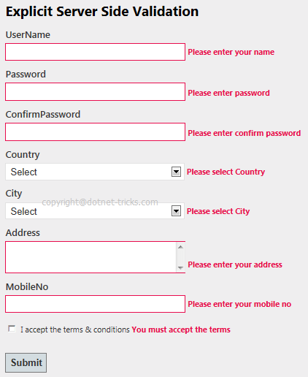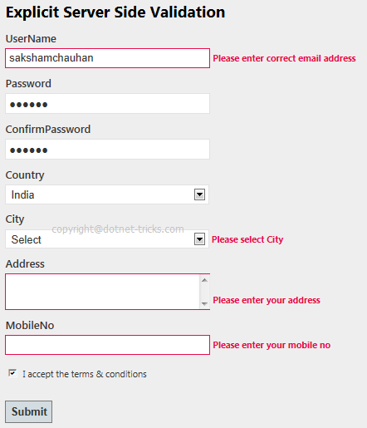
When all the validation will be passed then ModelState.IsValid returns true and you will be shown Completed view as shown in fig.
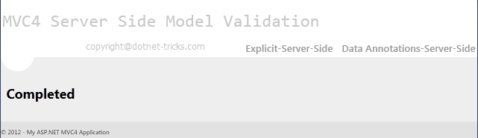

Model Validation with Data Annotations
The another and best way to validate a model by using Data Annotations. Data Annotations was introduced with .Net 3.5 SP1. It has a set of attributes and classes defined in the System.ComponentModel.DataAnnotations assembly. Data Annotations allow us to decorate model classes with metadata. This metadata describes a set of rules that are used to validate a property. For more help refer the article MVC Data Annotation.
In RegistrationModel.cs, I have defined one more model class RegistrationMetaModel by using data annotation and for which the view is defined as below:

RegistrationModel.cs
- public class RegistrationMetaModel
- {
- [Required(ErrorMessage = "Please Enter Email Address")]
- [Display(Name = "UserName (Email Address)")]
- [RegularExpression(".+@.+\\..+", ErrorMessage = "Please Enter Correct Email Address")]
- public string UserName { get; set; }

- [Required(ErrorMessage = "Please Enter Password")]
- [StringLength(50, ErrorMessage = "The {0} must be at least {2} characters long.", MinimumLength = 6)]
- [DataType(DataType.Password)]
- [Display(Name = "Password")]
- public string Password { get; set; }

- [Required(ErrorMessage = "Please Enter Confirm Password")]
- [StringLength(50, ErrorMessage = "The {0} must be at least {2} characters long.", MinimumLength = 6)]
- [DataType(DataType.Password)]
- [Display(Name = "Confirm password")]
- [Compare("Password", ErrorMessage = "The password and confirmation password do not match.")]
- public string ConfirmPassword { get; set; }

- [Display(Name = "Country")] [ValidCountryAttribute(ErrorMessage = "Please Select Country")]
- public Country Country { get; set; }

- [Display(Name = "City")]
- [ValidCityAttribute(ErrorMessage = "Please Select City")]
- public City City { get; set; }

- [Required(ErrorMessage = "Please Enter Address")]
- [Display(Name = "Address")]
- [MaxLength(200)]
- public string Address { get; set; }

- [Required(ErrorMessage = "Please Enter Mobile No")]
- [Display(Name = "Mobile")]
- [StringLength(10, ErrorMessage = "The Mobile must contains 10 characters", MinimumLength = 10)]
- public string MobileNo { get; set; }

- [MustBeTrue(ErrorMessage = "Please Accept the Terms & Conditions")]
- public bool TermsAccepted { get; set; }
- }

- public class MustBeTrueAttribute : ValidationAttribute
- {
- public override bool IsValid(object value)
- {
- return value is bool && (bool)value;
- }
- }
- public class ValidCountryAttribute : ValidationAttribute
- {
- public override bool IsValid(object value)
- {
- if (((Country)value).ID == null || ((Country)value).ID == 0)
- return false;
- else
- return true;
- }
- }
- public class ValidCityAttribute : ValidationAttribute
- {
- public override bool IsValid(object value)
- {
- if (((City)value).ID == null || ((City)value).ID == 0)
- return false;
- else
- return true;
- }
- }

ServerMeta.cshtml
- @model Mvc4_Model_ServerSideValidation.Models.RegistrationMetaModel
- @{
- ViewBag.Title = "Server Side Validation by Specifying Validation Rules Using Metadata";
- }
- <script src="../../Scripts/jquery-1.7.1.min.js" type="text/javascript"></script>
- <script type="text/jscript">
- $(function ()
- {
- $('#Country_ID').change(function ()
- {
- var id = $("#Country_ID :selected").val();
- if (id != "")
- {
- $.ajax({
- type: "GET",
- contentType: "application/json; charset=utf-8",
- url: '@Url.Action("CityList", "Home")',
- data: { "mCountry": id },
- dataType: "json",
- beforeSend: function () {
- },
- success: function (data) {
- var items = "";
- $.each(data, function (i, city) {
- items += "<option value='" + city.Value + "'>" + city.Text + "</option>";
- });
- $('#City_ID').html(items);
- },
- error: function (result) {
- alert('Service call failed: ' + result.status + ' Type :' + result.statusText);
- }
- });
- }
- else {
- var items = '<option value="">Select</option>';
- $('#City_ID').html(items);
- }
- });
- });
- </script>
- <h2>Server Side Validation by Specifying Validation Rules Using Metadata</h2>
- @using (Html.BeginForm())
- {
- <fieldset>
- <ol>
- <li>
- @Html.LabelFor(m => m.UserName)
- @Html.TextBoxFor(m => m.UserName, new { maxlength = 50 })
- @Html.ValidationMessageFor(m => m.UserName)
- </li>
- <li>
- @Html.LabelFor(m => m.Password)
- @Html.PasswordFor(m => m.Password, new { maxlength = 50, value = ViewBag.Selpwd })
- @Html.ValidationMessageFor(m => m.Password)
- </li>
- <li>
- @Html.LabelFor(m => m.ConfirmPassword)
- @Html.PasswordFor(m => m.ConfirmPassword, new { maxlength = 50, value = ViewBag.Selconfirmpwd })
- @Html.ValidationMessageFor(m => m.ConfirmPassword)
- </li>
- <li>
- @Html.LabelFor(m => m.Country)
- @Html.DropDownListFor(m => m.Country.ID, new SelectList(ViewBag.Country, "ID", "Name", ViewBag.SelCountry), new { style = "width:310px" })
- @Html.ValidationMessageFor(m => m.Country)
- </li>
- <li>
- @Html.LabelFor(m => m.City)
- @Html.DropDownListFor(m => m.City.ID, new SelectList(ViewBag.City, "ID", "Name", ViewBag.SelCity), new { style = "width:310px" })
- @Html.ValidationMessageFor(m => m.City)
- </li>
- <li>
- @Html.LabelFor(m => m.Address)
- @Html.TextAreaFor(m => m.Address, new { maxlength =200 })
- @Html.ValidationMessageFor(m => m.Address)
- </li>
- <li>
- @Html.LabelFor(m => m.MobileNo)
- @Html.TextBoxFor(m => m.MobileNo ,new { maxlength = 10 })
- @Html.ValidationMessageFor(m => m.MobileNo)
- </li>
- <li>
- @Html.CheckBoxFor(m => m.TermsAccepted) I accept the terms & conditions
- @Html.ValidationMessageFor(m => m.TermsAccepted)
- </li>
- </ol>
- <input type="submit" value="Submit" />
- </fieldset>
- }
Now let's see how we validate the model using data annotation?. To validate a model explicitly we need to validate received data with in the action method by checking ModelState.IsValid property. If it is false then error message will be shown automatically against each propety of model as shown below in fig.
- [HttpPost]
- public ActionResult ServerMeta(RegistrationMetaModel mRegister)
- {
- if (ModelState.IsValid)
- {
- return View("Completed");
- }
- else
- {
- ViewBag.Selpwd = mRegister.Password;
- ViewBag.Selconfirmpwd = mRegister.ConfirmPassword;
- BindCountry();

- if (mRegister.Country != null)
- BindCity(mRegister.Country.ID);
- else
- BindCity(null);
- return View();
- }
- }

How it works...
After running the project and navigating to Data Annotation-Server-Side page you will get the below page. When you press the submit button on this page then it will post the data to the server and the code written with in ServerMeta action will validate the input data by checking ModelState.IsValid property. If input data is not valid then ModelState.IsValid will return false and shown error as shown below.
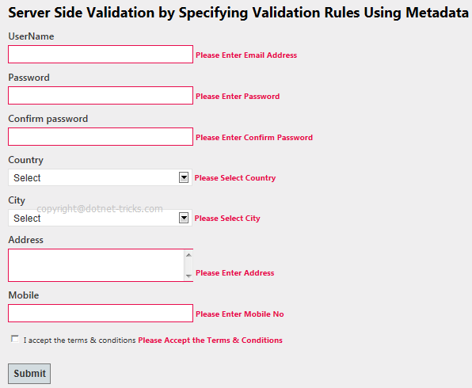&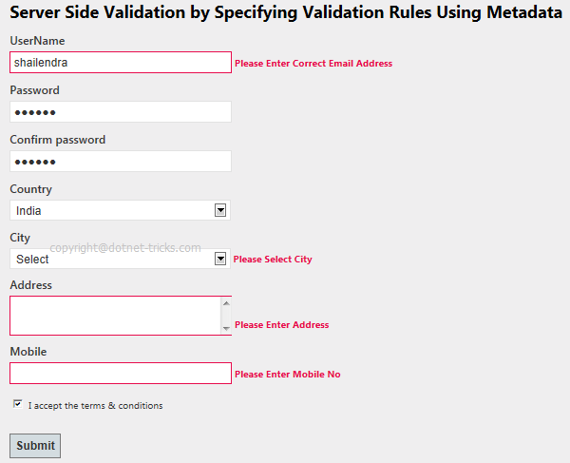
When all the validation will be passed then ModelState.IsValid returns true and you will be shown Completed view as shown in fig.

Difference Between Razor View Engine and ASPX View Engine
View Engine is responsible for rendering the view into html form to the browser. By default, Asp.net MVC support Web Form(ASPX) and Razor View Engine. There are many third party view engines (like Spark, Nhaml etc.) that are also available for Asp.net MVC. Now, Asp.net MVC is open source and can work with other third party view engines like Spark, Nhaml. In this article, I would like to expose the difference between Razor & Web Form View Engine.
Razor View Engine VS Web Form(ASPX) View Engine
Razor View Engine | Web Form View Engine
Razor Engine is an advanced view engine that was introduced with MVC3. This is not a new language but it is a new markup syntax. | Web Form Engine is the default view engine for the Asp.net MVC that is included with Asp.net MVC from the beginning.
The namespace for Razor Engine is System.Web.Razor. | The namespace for Webform Engine is System.Web.Mvc.WebFormViewEngine.
The file extensions used with Razor Engine are different from Web Form Engine. It has .cshtml (Razor with C#) or .vbhtml (Razor with VB) extension for views, partial views, editor templates and for layout pages. | The file extensions used with Web Form Engine are also like Asp.net Web Forms. It has .aspx extension for views, .ascx extension for partial views & editor templates and .master extension for layout/master pages.
Razor has new and advance syntax that are compact, expressive and reduces typing. | Web Form Engine has the same syntax like Asp.net Web Forms uses for .aspx pages.
Razor syntax are easy to learn and much clean than Web Form syntax. Razor uses @ symbol to make the code like as:  - @Html.ActionLink("SignUp", "SignUp") | Web Form syntax are borrowed from Asp.net Web Forms syntax that are mixed with html and sometimes make a view messy. Webform uses <% and %> delimiters to make the code like as:  - <%: Html.ActionLink("SignUp", "SignUp") %>
By default, Razor Engine prevents XSS attacks(Cross-Site Scripting Attacks) means it encodes the script or html tags like <,> before rendering to view. | Web Form Engine does not prevent XSS attacks means any script saved in the database will be fired while rendering the page
Razor Engine is little bit slow as compared to Webform Engine. | Web Form Engine is faster than Razor Engine.
Razor Engine, doesn't support design mode in visual studio means you cannot see your page look and feel. | Web Form engine support design mode in visual studio means you can see your page look and feel without running the application.
Razor Engine support TDD (Test Driven Development) since it is not depend on System.Web.UI.Page class. | Web Form Engine doesn't support TDD (Test Driven Development) since it depend on System.Web.UI.Page class which makes the testing complex.

How to Enable and Disable Client-Side Validation in MVC
MVC3 & MVC4 supports unobtrusive client-side validation. In which validation rules are defined using attributes added to the generated HTML elements. These rules are interpreted by the included JavaScript library and uses the attribute values to configure the jQuery Validation library which does the actual validation work. In this article, I would like to demonstrate various ways for enabling or disabling the client side validation.

Enable Client-Side Validation in MVC
For enabling client side validation, we required to include the jQuery min, validate & unobtrusive scripts in our view or layout page in the following order.
- <script src="@Url.Content("~/Scripts/jquery-1.6.1.min.js")" type="text/javascript"></script>
- <script src="@Url.Content("~/Scripts/jquery.validate.js")" type="text/javascript"></script>
- <script src="@Url.Content("~/Scripts/jquery.validate.unobtrusive.js")" type="text/javascript"></script>
The order of included files as shown above, is fixed since below javascript library depends on top javascript library.

Enabling and Disabling Client-Side Validation at Application Level
We can enable and disable the client-side validation by setting the values of ClientValidationEnabled & UnobtrusiveJavaScriptEnabled keys true or false. This setting will be applied to application level.
- <appSettings>
- <add key="ClientValidationEnabled" value="true"/>
- <add key="UnobtrusiveJavaScriptEnabled" value="true"/>
- </appSettings>
For client-side validation, the values of above both the keys must be true. When we create new project using Visual Studio in MVC3 or MVC4, by default the values of both the keys are set to true.
We can also enable the client-side validation programmatically. For this we need to do code with in the Application_Start() event of the Global.asax, as shown below.
- protected void Application_Start()
- {
- //Enable or Disable Client Side Validation at Application Level
- HtmlHelper.ClientValidationEnabled = true;
- HtmlHelper.UnobtrusiveJavaScriptEnabled = true;
- }

Enabling and Disabling Client-Side Validation for Specific View
We can also enable or disable client-side validation for a specific view. For this we required to enable or disable client side validation inside a Razor code block as shown below. This option will overrides the application level settings for that specific view.
- @model MvcApp.Models.Appointment
- @{
- ViewBag.Title = "Make A Booking";
- HtmlHelper.ClientValidationEnabled = false;
- }
- ...

Custom Validation for Cascading Dropdownlist in MVC Razor
This article will demonstrate, how to make and validate cascading dropdown list with in Asp.Net MVC4 Razor application using custom server-side and client-side validation. In this article, you will learn how set selected value with in Dropdown list in MVC Razor.

How to do it..
Follow the following steps for making and validating cascading dropdown list in mvc razor.

Step 1 : Design Model
- using System;
- using System.Collections.Generic;
- using System.Linq;
- using System.Web;
- using System.ComponentModel.DataAnnotations;
- using System.Web.Mvc;
- using System.Text.RegularExpressions;
- namespace Mvc4_Validate_CascadingDropdown.Models
- {
- public class RegistrationModel
- {
- [Required(ErrorMessage = "Please Enter Email Address")]
- [Display(Name = "UserName (Email Address)")]
- [RegularExpression(".+@.+\\..+", ErrorMessage = "Please Enter Correct Email Address")]
- public string UserName { get; set; }
- [Display(Name = "Country")]
- public Country Country { get; set; }
- [Display(Name = "City")]
- public City City { get; set; }
- [Required(ErrorMessage = "Please Enter Address")]
- [Display(Name = "Address")]
- [StringLength(200)]
- public string Address { get; set; }
- }
- // IClientValidatable for client side Validation
- public class MustBeSelectedAttribute : ValidationAttribute, IClientValidatable
- {
- public override bool IsValid(object value) {
- if (value == null || (int)value == 0)
- return false;
- else return true;
- }
- // Implement IClientValidatable for client side Validation
- public IEnumerable GetClientValidationRules(ModelMetadata metadata, ControllerContext context)
- {
- return new ModelClientValidationRule[]
- {
- new ModelClientValidationRule { ValidationType = "dropdown", ErrorMessage = this.ErrorMessage } };
- }
- }
- public class Country
- {
- [MustBeSelectedAttribute(ErrorMessage = "Please Select Country")]
- public int? ID { get; set; }
- public string Name { get; set; }
- }
- public class City
- {
- [MustBeSelectedAttribute(ErrorMessage = "Please Select City")]
- public int? ID { get; set; }
- public string Name { get; set; }
- public int? Country { get; set; }
- }
- }

Step 2: Design View based on Model
- @model Mvc4_Validate_CascadingDropdown.Models.RegistrationModel
- @{ ViewBag.Title = "Validating Cascading Dropdownlist";
- }
- <script src="../../Scripts/jquery-1.7.1.min.js" type="text/javascript"></script>
- <script src="../../Scripts/jquery.validate.min.js" type="text/javascript"></script>
- <script src="../../Scripts/jquery.validate.unobtrusive.min.js" type="text/javascript"></script>
- <script type="text/jscript">
- //Custom jQuery validation unobtrusive script and adapters
- jQuery.validator.unobtrusive.adapters.add("dropdown", function (options) {
- if (options.element.tagName.toUpperCase() == "SELECT" && options.element.type.toUpperCase() == "SELECT-ONE") {
- options.rules["required"] = true;
- if (options.message) {
- options.messages["required"] = options.message;
- }
- }
- });
- $(function () {
- //get city list on changing of country dropdown list
- $('#Country_ID').change(function () {
- var id = $("#Country_ID :selected").val();
- if (id != "") {
- $.ajax({
- type: "GET",
- contentType: "application/json; charset=utf-8",
- url: '@Url.Action("CityList", "Home")',
- data: { "mCountry": id },
- dataType: "json",
- beforeSend: function () {
- //alert(id);
- },
- success: function (data) {
- var items = "";
- $.each(data, function (i, city) {
- items += "<option value='" + city.Value + "'>" + city.Text + "</option>";
- });
- // Fill City Dropdown list
- $('#City_ID').html(items);
- },
- error: function (result) {
- alert('Service call failed: ' + result.status + ' Type :' + result.statusText);
- }
- });
- }
- else {
- var items = '<option value="">Select</option>';
- $('#City_ID').html(items);
- }
- });
- });
- </script>
- <h2>Custom Validation for Cascading Dropdown List</h2>
- @using (Html.BeginForm())
- {
- <fieldset> <legend>Custom Validation for Cascading Dropdown List</legend>
- <ol> <li>
- @Html.LabelFor(m => m.UserName)
- @Html.TextBoxFor(m => m.UserName, new { maxlength = 50 })
- @Html.ValidationMessageFor(m => m.UserName) </li>
- <li>
- @Html.LabelFor(m => m.Country)
- @Html.DropDownListFor(m => m.Country.ID, new SelectList(ViewBag.Country, "ID", "Name", ViewBag.SelCountry), new { style = "width:310px" })
- @Html.ValidationMessageFor(m => m.Country.ID)
- </li>
- <li>
- @Html.LabelFor(m => m.City)
- @Html.DropDownListFor(m => m.City.ID, new SelectList(ViewBag.City, "ID", "Name", ViewBag.SelCity), new { style = "width:310px" })
- @Html.ValidationMessageFor(m => m.City.ID)
- </li>
- <li>
- @Html.LabelFor(m => m.Address)
- @Html.TextAreaFor(m => m.Address, new { maxlength = 200 })
- @Html.ValidationMessageFor(m => m.Address)
- </li>
- </ol>
- <input type="submit" value="Submit" />
- </fieldset>
- }

Design Controller Based on Model & View
- using System;
- using System.Collections.Generic;
- using System.Linq;
- using System.Web;
- using System.Web.Mvc;
- using Mvc4_Validate_CascadingDropdown.Models;
- using System.Text.RegularExpressions;
- namespace Mvc4_Validate_CascadingDropdown.Controllers {
- public class HomeController : Controller {
- #region Private Methods
- void BindCountry() {
- List<Country> lstCountry = new List<Country>
- {
- new Country { ID = null, Name = "Select" },
- new Country { ID = 1, Name = "India" },
- new Country { ID = 2, Name = "USA" } };
- ViewBag.Country = lstCountry;
- }
- //for server side
- void BindCity(int? mCountry) {
- try {
- if (mCountry != 0)
- {
- //below code is only for demo, you can pick city from database
- int index = 1;
- List<City> lstCity = new List<City>{
- new City { Country = 0, ID=null, Name = "Select" },
- new City { Country = 1, ID=index++, Name = "Delhi" },
- new City { Country = 1, ID=index++, Name = "Lucknow" },
- new City { Country = 1, ID=index++, Name = "Noida" },
- new City { Country = 1, ID=index++, Name = "Guragon" },
- new City { Country = 1, ID=index++, Name = "Pune" },
- new City { Country = 2, ID=index++, Name = "New-York" },
- new City { Country = 2, ID=index++, Name = "California" },
- new City { Country = 2, ID=index++, Name = "Washington" },
- new City { Country = 2, ID=index++, Name = "Vermont" }, };
- var city = from c in lstCity
- where c.Country == mCountry || c.Country == 0
- select c;
- ViewBag.City = city;
- }
- else {
- List<City> City = new List<City> {
- new City { ID = null, Name = "Select" } };
- ViewBag.City = City;
- }
- }
- catch (Exception ex) {
- }
- }
- #endregion
- //for client side using jquery
- public JsonResult CityList(int mCountry) {
- try {
- if (mCountry != 0) {
- //below code is only for demo, you can pick city from database
- int index = 1;
- List<City> lstCity = new List<City>{
- new City { Country = 0, ID=null, Name = "Select" },
- new City { Country = 1, ID=index++, Name = "Delhi" },
- new City { Country = 1, ID=index++, Name = "Lucknow" },
- new City { Country = 1, ID=index++, Name = "Noida" },
- new City { Country = 1, ID=index++, Name = "Guragon" },
- new City { Country = 1, ID=index++, Name = "Pune" },
- new City { Country = 2, ID=index++, Name = "New-York" },
- new City { Country = 2, ID=index++, Name = "California" },
- new City { Country = 2, ID=index++, Name = "Washington" },
- new City { Country = 2, ID=index++, Name = "Vermont" }, };
- var city = from c in lstCity
- where c.Country == mCountry || c.Country == 0
- select c;
- return Json(new SelectList(city.ToArray(), "ID", "Name"), JsonRequestBehavior.AllowGet);
- }
- }
- catch (Exception ex) {
- }
- return Json(null);
- }
- public ActionResult Index()
- {
- return View();
- }
- public ActionResult CustomDropdown()
- {
- BindCountry();
- BindCity(0);
- return View();
- }
- [HttpPost]
- public ActionResult CustomDropdown(RegistrationModel mRegister)
- {
- if (ModelState.IsValid)
- {
- return View("Completed");
- }
- else
- {
- ViewBag.SelCountry = mRegister.Country;
- BindCountry();
- ViewBag.SelCity = mRegister.City;
- if (mRegister.Country != null)
- BindCity(mRegister.Country.ID);
- else
- BindCity(null);
- return View();
- }
- }
- }
- }

How it works..
It's time to run the project and let's see the result as shown below :
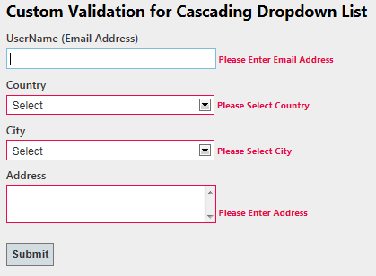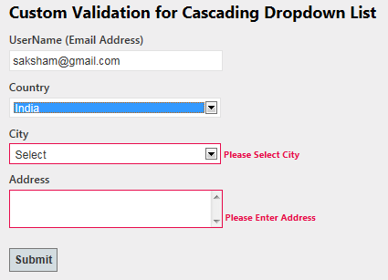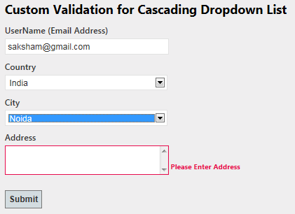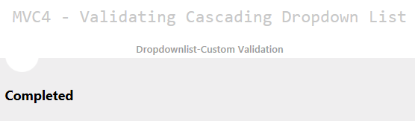

Custom Validation for Checkbox in MVC Razor
This article will demonstrate, how to check whether checkbox is checked or not in Asp.Net MVC4 Razor application using custom server-side and client-side validation.

How to do it..
Follow the following steps for validating checkbox in mvc razor.

Step 1 : Making Custom Attribute
- public class RegistrationModel {
- [Required(ErrorMessage = "Please Enter Email Address")]
- [RegularExpression(".+@.+\\..+", ErrorMessage = "Please Enter Correct Email Address")]
- public string UserName { get; set; }
- [Required(ErrorMessage = "Please Enter Address")]
- [Display(Name = "Address")]
- public string Address { get; set; }
- // Applying Custom Attribute
- [MustBeTrue(ErrorMessage = "Please Accept the Terms & Conditions")]
- public bool TermsAccepted { get; set; } }
- //Making Custom attribute for validating checkbox
- // IClientValidatable for client side Validation
- public class MustBeTrueAttribute : ValidationAttribute, IClientValidatable
- {
- public override bool IsValid(object value)
- {
- return value is bool && (bool)value;
- }
- // Implement IClientValidatable for client side Validation
- public IEnumerable<ModelClientValidationRule> GetClientValidationRules(ModelMetadata metadata, ControllerContext context)
- {
- return new ModelClientValidationRule[] {
- new ModelClientValidationRule { ValidationType = "checkboxtrue", ErrorMessage = this.ErrorMessage } };
- }
- }

Step 2: Making Custom Validation using jQuery
- @model Mvc4_Model_ServerSideValidation.Models.RegistrationModel
- @{
- ViewBag.Title = "Validating CheckBox";
- }
- <script src="../../Scripts/jquery-1.7.1.min.js" type="text/javascript"></script>
- <script src="../../Scripts/jquery.validate.min.js" type="text/javascript"></script>
- <script src="../../Scripts/jquery.validate.unobtrusive.min.js" type="text/javascript"></script>
- <script type="text/jscript">
- //Custom jQuery validation unobtrusive script and adapters
- jQuery.validator.unobtrusive.adapters.add("checkboxtrue", function (options)
- {
- if (options.element.tagName.toUpperCase() == "INPUT" && options.element.type.toUpperCase() == "CHECKBOX")
- {
- options.rules["required"] = true;
- if (options.message) {
- options.messages["required"] = options.message;
- }
- }
- }); </script>
- <h2>Custom Validation for CheckBox </h2>
- @using (Html.BeginForm())
- {
- <fieldset>
- <legend>Custom Validation for Cascading Dropdown List</legend>
- <ol>
- <li>
- @Html.LabelFor(m => m.UserName)
- @Html.TextBoxFor(m => m.UserName, new { maxlength = 50 })
- @Html.ValidationMessageFor(m => m.UserName)
- </li>
- <li>
- @Html.LabelFor(m => m.Address)
- @Html.TextAreaFor(m => m.Address, new { maxlength = 200 })
- @Html.ValidationMessageFor(m => m.Address)
- </li>
- <li>
- @Html.CheckBoxFor(m => m.TermsAccepted)
- @Html.ValidationMessageFor(m => m.TermsAccepted)
- </li>
- </ol>
- <input type="submit" value="Submit" />
- </fieldset>
- }

How it works..
Now, you have applied the custom validation to the checkbox. This validation works for client-side and server side.

ASP.NET MVC Registration form with Validation
Since registration form is a common form, so I prefer it to demonstrate the basic validation in ASP.NET MVC. I have already explained the validation with data annotation and how to enable client side validation in mvc razor, now my focus is to develop registration form with client side and server side validations.

How to do it...

Step1 : Designing Model
First of all we will design the RegistrationModel with data annotation which help us to validate the input data. Since we have no attribute to validate drop down list and checkbox, so I have created custom attributes "MustBeSelected" and "MustBeTrue for validating dropdownlist and checkbox respectively as shown below.
- public class RegistrationModel
- {
- [Required(ErrorMessage = "Please Enter Email Address")]
- [Display(Name = "UserName")]
- [RegularExpression(".+@.+\\..+", ErrorMessage = "Please Enter Correct Email Address")]
- public string UserName { get; set; }

- [Required(ErrorMessage = "Please Enter Password")]
- [StringLength(50, ErrorMessage = "The {0} must be at least {2} characters long.", MinimumLength = 6)]
- [DataType(DataType.Password)]
- [Display(Name = "Password")]
- public string Password { get; set; }

- [Required(ErrorMessage = "Please Enter Confirm Password")]
- [StringLength(50, ErrorMessage = "The {0} must be at least {2} characters long.", MinimumLength = 6)]
- [DataType(DataType.Password)]
- [Display(Name = "Confirm password")]
- [Compare("Password", ErrorMessage = "The password and confirmation password do not match.")]
- public string ConfirmPassword { get; set; }

- [Display(Name = "Country")]
- public Country Country { get; set; }

- [Display(Name = "City")]
- public City City { get; set; }

- [Required(ErrorMessage = "Please Enter Address")]
- [Display(Name = "Address")]
- [StringLength(200)]
- public string Address { get; set; }

- [Required(ErrorMessage = "Please Enter Mobile No")]
- [Display(Name = "Mobile")]
- [StringLength(10, ErrorMessage = "The Mobile must contains 10 characters", MinimumLength = 10)]
- public string MobileNo { get; set; }

- [MustBeTrue(ErrorMessage = "Please Accept the Terms & Conditions")]
- public bool TermsAccepted { get; set; }
- }

- public class MustBeTrueAttribute : ValidationAttribute, IClientValidatable // IClientValidatable for client side Validation
- {
- public override bool IsValid(object value)
- {
- return value is bool && (bool)value;
- }
- // Implement IClientValidatable for client side Validation
- public IEnumerable<ModelClientValidationRule> GetClientValidationRules(ModelMetadata metadata, ControllerContext context)
- {
- return new ModelClientValidationRule[] { new ModelClientValidationRule { ValidationType = "checkbox", ErrorMessage = this.ErrorMessage } };
- }
- }

- public class MustBeSelected : ValidationAttribute, IClientValidatable // IClientValidatable for client side Validation
- {
- public override bool IsValid(object value)
- {
- if (value == null || (int)value == 0)
- return false;
- else
- return true;
- }
- // Implement IClientValidatable for client side Validation
- public IEnumerable<ModelClientValidationRule> GetClientValidationRules(ModelMetadata metadata, ControllerContext context)
- {
- return new ModelClientValidationRule[] { new ModelClientValidationRule { ValidationType = "dropdown", ErrorMessage = this.ErrorMessage } };
- }
- }

- public class Country
- {
- [MustBeSelected(ErrorMessage = "Please Select Country")]
- public int? ID { get; set; }
- public string Name { get; set; }
- }

- public class City
- {
- [MustBeSelected(ErrorMessage = "Please Select City")]
- public int? ID { get; set; }
- public string Name { get; set; }
- public int? Country { get; set; }
- }

- }
As shown above, for creating custom attribute you need to inherit ValidationAttribute class and IClientValidatable interface for Server Side and Client Side Validation.

Step2 : Designing View
Now design the strongly-typed view on the basis of Registration Model. We will also register the client side validation that we have defined in model for the dropdownlist and checkbox by using jquery as shown below.
- @model Mvc4_RegistrationForm.Models.RegistrationModel
- <script type="text/jscript">
- jQuery.validator.unobtrusive.adapters.add("dropdown", function (options) {
- if (options.element.tagName.toUpperCase() == "SELECT" && options.element.type.toUpperCase() == "SELECT-ONE") {
- options.rules["required"] = true;
- if (options.message) {
- options.messages["required"] = options.message;
- }
- }
- });

- jQuery.validator.unobtrusive.adapters.add("checkbox", function (options) {
- if (options.element.tagName.toUpperCase() == "INPUT" && options.element.type.toUpperCase() == "CHECKBOX") {
- options.rules["required"] = true;
- if (options.message) {
- options.messages["required"] = options.message;
- }
- }
- });

- $(function () {
- $('#Country_ID').change(function () {
- var id = $("#Country_ID :selected").val();
- if (id != "") {
- $.ajax({
- type: "GET",
- contentType: "application/json; charset=utf-8",
- url: '@Url.Action("CityList", "Home")',
- data: { "mCountry": id },
- dataType: "json"
- success: function (data) {
- var items = "";
- $.each(data, function (i, city) {
- items += "<option value='" + city.Value + "'>" + city.Text + "</option>";
- });
- $('#City_ID').html(items);
- },
- error: function (result) {
- alert('Service call failed: ' + result.status + ' Type :' + result.statusText);
- }
- });
- }
- else {
- var items = '<option value="">Select</option>';
- $('#City_ID').html(items);
- }
- });

- });

- </script>

- @using (Html.BeginForm())
- {
- lt;fieldset>
- <legend></legend>
- <ol>
- <li>
- @Html.LabelFor(m => m.UserName)
- @Html.TextBoxFor(m => m.UserName, new { maxlength = 50 })
- @Html.ValidationMessageFor(m => m.UserName)
- </li>
- <li>
- @Html.LabelFor(m => m.Password)
- @Html.PasswordFor(m => m.Password, new { maxlength = 50, value = ViewBag.Selpwd })
- @Html.ValidationMessageFor(m => m.Password)
- </li>
- <li>
- @Html.LabelFor(m => m.ConfirmPassword)
- @Html.PasswordFor(m => m.ConfirmPassword, new { maxlength = 50, value = ViewBag.Selconfirmpwd })
- @Html.ValidationMessageFor(m => m.ConfirmPassword)
- </li>
- <li>
- @Html.LabelFor(m => m.Country)
- @Html.DropDownListFor(m => m.Country.ID, new SelectList(ViewBag.Country, "ID", "Name", ViewBag.SelCountry), new { style = "width:310px" })
- @Html.ValidationMessageFor(m => m.Country.ID)
- </li>
- lt;li>
- @Html.LabelFor(m => m.City)
- @Html.DropDownListFor(m => m.City.ID, new SelectList(ViewBag.City, "ID", "Name", ViewBag.SelCity), new { style = "width:310px" })
- @Html.ValidationMessageFor(m => m.City.ID)
- </li>
- <li>
- @Html.LabelFor(m => m.Address)
- @Html.TextAreaFor(m => m.Address, new { maxlength =200 })
- @Html.ValidationMessageFor(m => m.Address)
- </li>
- <li>
- @Html.LabelFor(m => m.MobileNo)
- @Html.TextBoxFor(m => m.MobileNo ,new { maxlength = 10 })
- @Html.ValidationMessageFor(m => m.MobileNo)
- </li>
- <li>
- @Html.CheckBoxFor(m => m.TermsAccepted) I accept the terms & conditions
- @Html.ValidationMessageFor(m => m.TermsAccepted)
- </li>
- </ol>
- <input type="submit" value="Submit" />
- </fieldset>
- }

Step3 : Designing Controller
In the controller defined the methods for binding Country and City dropdown lists. I am not showing the methods here. Also handle the submit button event. We should also check all the validation at server side by checking IsValid property of ModelState.
- public ActionResult RegistrationForm()
- {
- BindCountry();
- BindCity(0);
- return View();
- }

- [HttpPost]
- public ActionResult RegistrationForm(RegistrationModel mRegister)
- {
- //This will check Server Side Validation by using data annotation
- if (ModelState.IsValid)
- {
- return View("Completed");
- }
- else
- {
- // To DO: if client validation failed
- ViewBag.Selpwd = mRegister.Password; //for setting password value
- ViewBag.Selconfirmpwd = mRegister.ConfirmPassword;
- ViewBag.SelCountry = mRegister.Country; // for setting selected country
- BindCountry();
- ViewBag.SelCity = mRegister.City;// for setting selected city

- if (mRegister.Country != null)
- BindCity(mRegister.Country.ID);
- else
- BindCity(null);

- return View();
- }
- }

How it works...
Now run the code and you will find that all the validations are working well as expected.

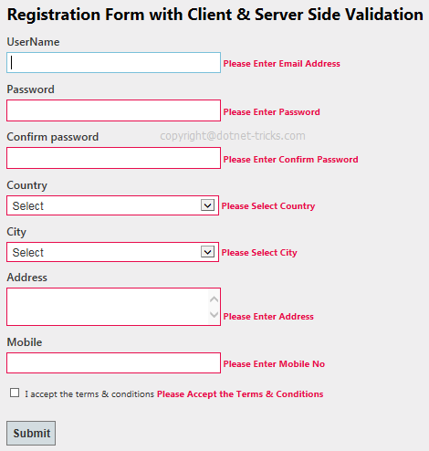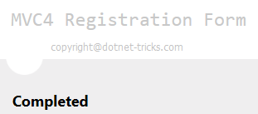

Routing in Asp.Net MVC with example
Basically, Routing is a pattern matching system that monitor the incoming request and figure out what to do with that request. At runtime, Routing engine use the Route table for matching the incoming request's URL pattern against the URL patterns defined in the Route table. You can register one or more URL patterns to the Route table at Application_Start event. MVC5 also supports attribute routing, to know more refer Attribute Routing in ASP.NET MVC.

How to define route...
- public static void RegisterRoutes(RouteCollection routes)
- {
- routes.MapRoute(
- "Default", // Route name
- "{controller}/{action}/{id}", // Route Pattern
- new { controller = "Home", action = "Index", id = UrlParameter.Optional } // Default values for above defined parameters
- );
- }

- protected void Application_Start()
- {
- RegisterRoutes(RouteTable.Routes);
- //To:DO
- }
When the routing engine finds a match in the route table for the incoming request's URL, it forwards the request to the appropriate controller and action. If there is no match in the route table for the incoming request's URL, it returns a 404 HTTP status code.

Note
Always remember route name should be unique across the entire application. Route name can’t be duplicate.

How it works...
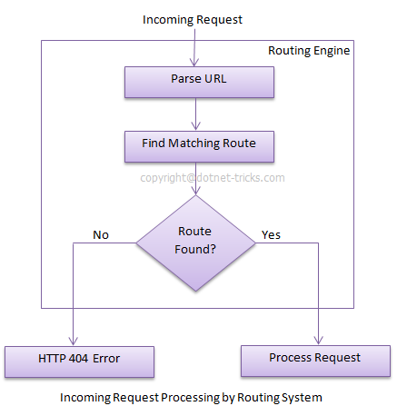
In above example we have defined the Route Pattern {controller}/{action}/{id} and also provide the default values for controller,action and id parameters. Default values means if you will not provide the values for controller or action or id defined in the pattern then these values will be serve by the routing system.
Suppose your webapplication is running on www.example.com then the url pattren for you application will be www.example.com/{controller}/{action}/{id}. Hence you need to provide the controller name followed by action name and id if it is required. If you will not provide any of the value then default values of these parameters will be provided by the routing system. Here is a list of URLs that match and don't match this route pattern.
Matching URLs
Request URL | Parameters
http://example.com/ | controller=Home, action=Index, id=none, Since default value of controller and action are Home and Index respectively.
http://example.com/Admin | controller=Admin, action=Index, id=none, Since default value of action is Index
http://example.com/Admin/Product | controller=Admin, action=Product, id=none
http://example.com/Admin/Product/1 | controller=Admin, action=Product, id=1
http://example.com/Admin/Product/SubAdmin/1 | No Match Found
http://example.com/Admin/Product/SubAdmin/Add/1 | No Match Found

Difference between Routing and URL Rewriting
Many developers compare routing to URL rewriting that is wrong. Since both the approaches are very much different. Moreover, both the approaches can be used to make SEO friendly URLs. Below is the main difference between these two approaches.
- URL rewriting is focused on mapping one URL (new url) to another URL (old url) while routing is focused on mapping a URL to a resource.
- Actually, URL rewriting rewrites your old url to new one while routing never rewrite your old url to new one but it map to the original route.

Route Constraints in Asp.Net MVC with example
In previous article, I have described the Routing and how to create route in your application. Now the time is how to control the behavior of a route. Basically route constraints is way to put some validation around the defined route.

Creating Route Constraints
Suppose we have defined the following route in our application and you want to restrict the incoming request url with numeric id only.Now let's see how to do it with the help of regular expression.
- routes.MapRoute(
- "Default", // Route name
- "{controller}/{action}/{id}", // Route Pattern
- new { controller = "Home", action = "Index", id = UrlParameter.Optional } // Default values for parameters
- );

